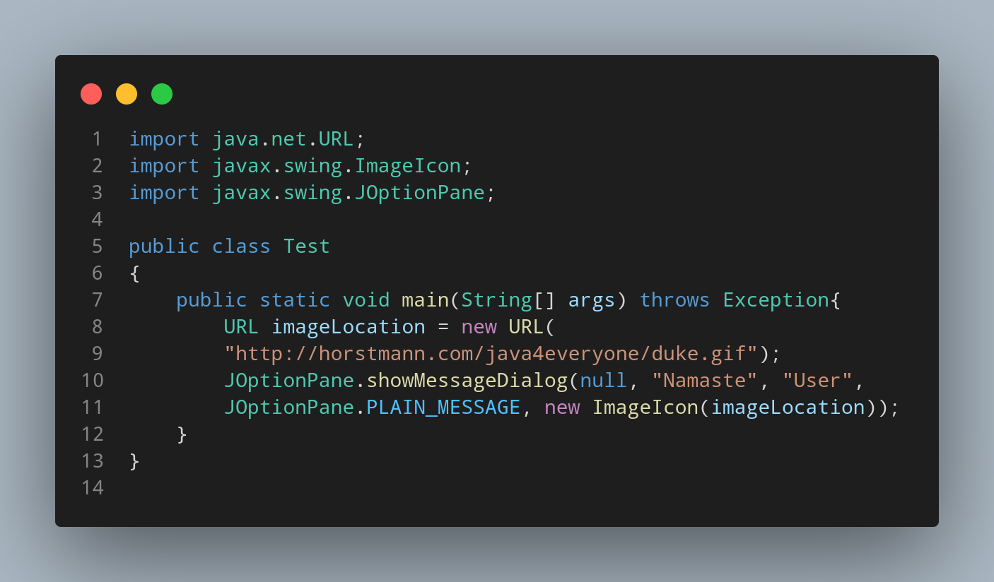

#Doc

First we import our java.net.URL; in order to use provide link reader in our program.

Instantiate URL class providing link of image for icon.

we import our javax.swing.JoptionPane in order to use JoptionPane.

File name Test is created so we create a class name Test, inside the class we created a main function. Then we use our JoptionPane class to make a popup dialogbox where through our showMessageDialog function to show our required massage in our created dialog box.

At last JoptionPane.PLAIN_MESSAGE and ImageIcon are used to display dialog box having icon on it with given message.

